**“Ballistic Devices Documentation”**

In Partial Fulfillment of the Requirements in the Major Subject

**Modeling and Simulation**

**Submitted by:**

Ciudad, Reome Jay

Juat, Jan Maverick

Pabalan, Mark Jeremiah

Prudente, Lady Marah

Reus, Alleah

Soriano, Stephanie Elenn

Turado, Jasper

**Submitted to:**

Prof. Angelica P. Payne, LPT  
**Modeling and Simulation Adviser**

February 2023

**TABLE OF CONTENTS**

COVER PAGE 1

FLOW CHART 3

INSTRUCTION MANUAL 4 - 5

**FLOWCHART**

**INSTRUCTIONAL MANUAL**

The application is a very basic simulation of the trajectory of projectile motion with the influence of gravity and air resistance. The application will display its motion from the ground given an angle and set initial velocity for every given point in time until hits the ground again. With the help of this application, we can see where an object would be given the parameters in an ideal scenario.

1. **Interface**

The Interface provide measurements for the position of the ball for every point in time.

1. **Usage**

**Selection**

**A. Home Window**

**There are 3 buttons in the Home Window:**

|  |  |
| --- | --- |
| **Function** | |
| Simulate | Go to the Selection Window. |
| Help | Go to the Help Window. |
| Exit | Terminate the System. |

1. **Selection Window**

Users can select ballistic devices they want to simulate. There are 3 ballistic devices in the app: golf ball, bow/arrow, and gun/bullet.

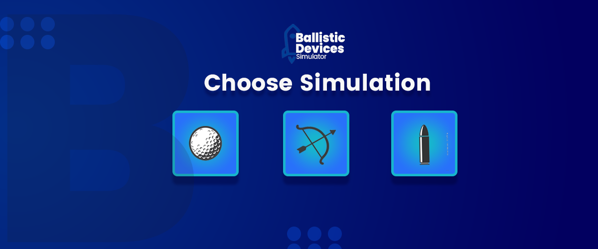

|  |  |
| --- | --- |
| **Select a ballistic device** | |
| Golf | Simulate the projectile motion of a golf ball. |
| Bow and Arrow | Simulate the trajectory of a Bow and Arrow. |
| Gun/Bullet | Simulate the effects of projectiles to a gun. |

1. **Help Window**

Provides background of the simulator, and directions/guides.

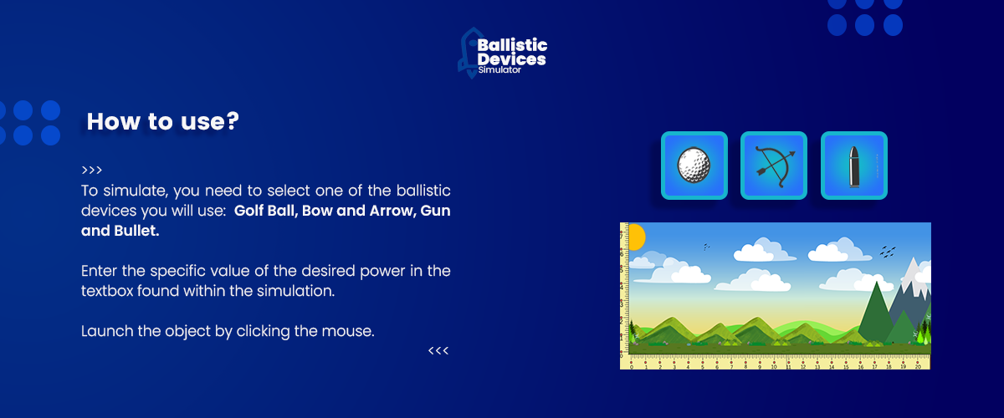

**Simulation**

|  |  |
| --- | --- |
| **To simulate** | |
| Aiming | The launch angle will be determined by the position of the cursor with respect to the position of the ball. |
| Shooting | Any MouseEvent detected will launch the ball in the same angle as the mouse with the initial position of the object as its origin. |
| Marking | When the ball reaches the ground, the object will be left in place |